
WE ARE LOCATED HERE:


There are several daily flights between Haugesund Airport Karmøy and Oslo Airport Gardermoen. Haugesund is located between the international airports of Stavanger and Bergen. From Stavanger there is an express bus to Haugesund, and the drive takes approx. 1.5 hours. From Bergen there is a flight to Haugesund, or an express bus which takes approx. 2.5 hours.

ACCOMMODATION:
Home Hotel Amanda | Thon Partner Hotel Saga
 | 

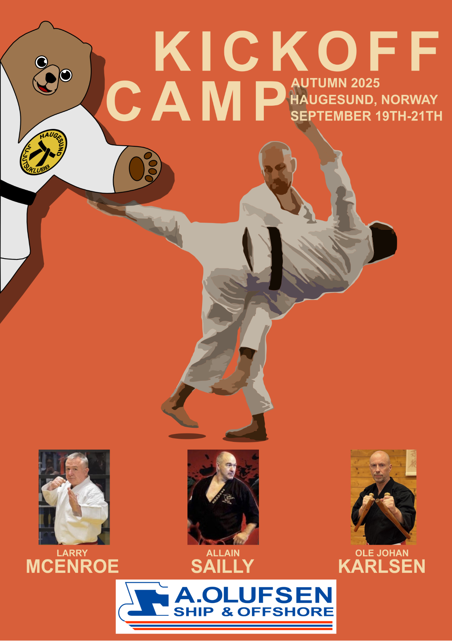
WELCOME!
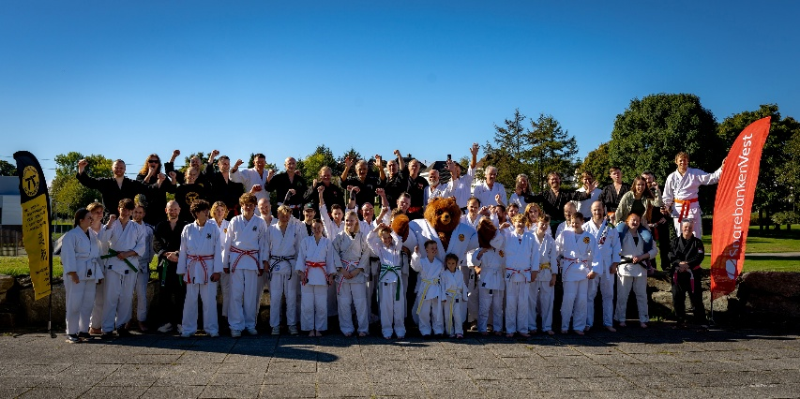
We at Haugesund ju-jutsu club are pleased to invite you to the autumn kickoff 2025! Autumn is the time to start again, get started with training and set new goals. What better way than to kick it all off together with good friends and inspiring instructors? Welcome to Haugesund, the homeland of the Viking kings!
REGISTER HERE:
 | Or go to:  WWW.HJJK.NO

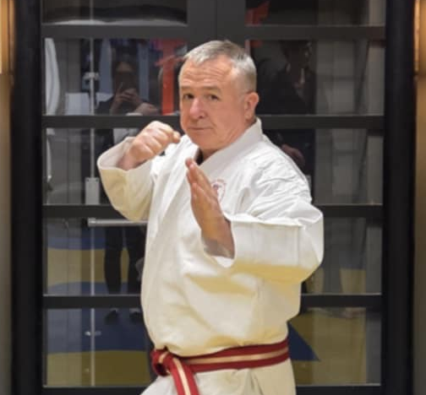
We are delighted to have HANSHI LARRY MCENROE from Kilkenny, Ireland as our instructor for this year's camp. McEnroe has extensive experience in a wide range of disciplines and is very knowledgeable. He has been an unarmed combat instructor for the Irish Defence Forces and is Vice President of Jiu Jitsu International. He is graded 8th dan in jiu jitsu, 5th dan in kyujitsu and 1st dan in kenjutsu. We look forward to getting to know him, both on the mat and as a person!
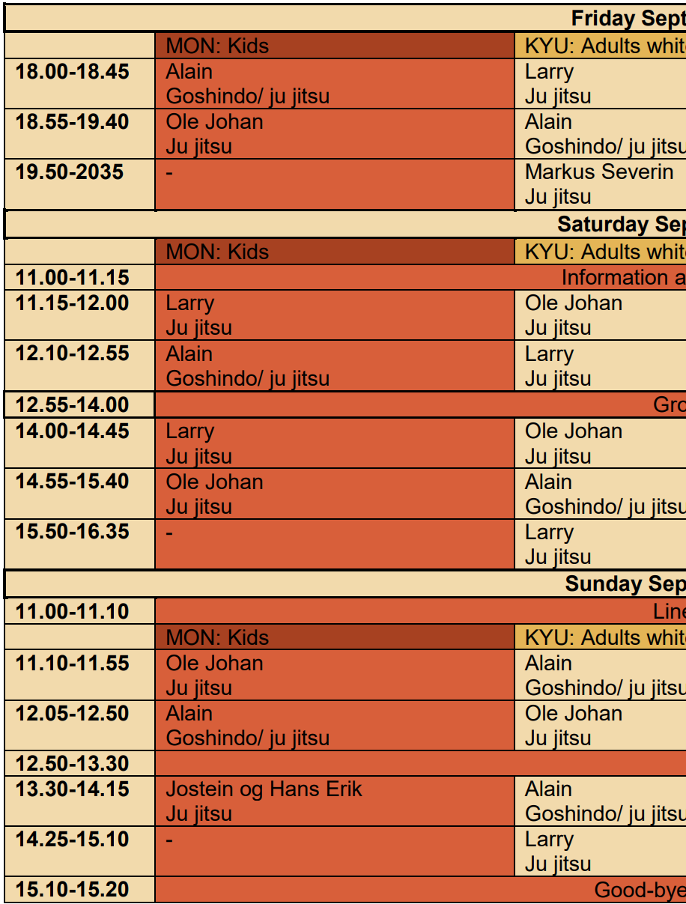
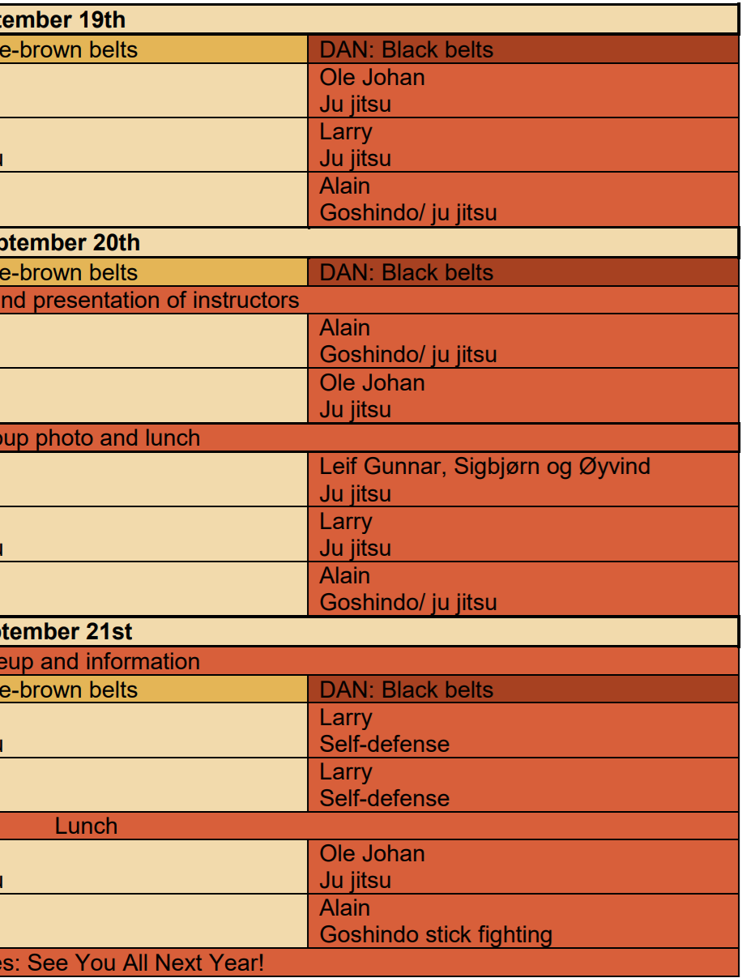

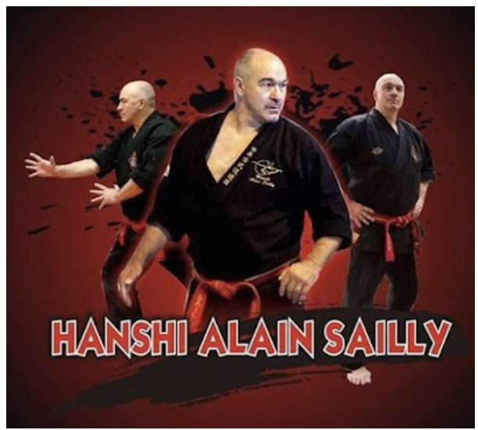
HANSHI ALAIN SAILLY is a well-known name to martial arts enthusiasts worldwide. He started judo at the age of 5. In his teens and early 20s, he competed at the international level in judo, freestyle and Greco-Roman wrestling, sambo and full-contact ju jitsu. Sailly is an international ambassador for the World Kobudo Federation, and annually visits approximately 30 countries with the aim of spreading their knowledge and values. He is a 9th dan Goshindo. In addition to being a martial artist like no other, he is a wonderful person who cares for everyone he meets. We look forward to training and being with our friend from France once again!
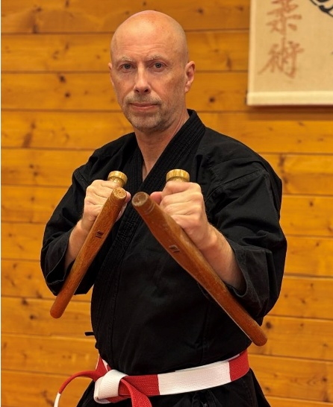

SHIHAN OLE JOHAN KARLSEN is the head instructor at Stavanger Ju Jitsu Club. We know Ole Johan as a very skilled instructor with a wealth of knowledge and a lot of energy. Ole Johan has trained Ju Jitsu since 1980, and is the first to achieve a black belt in ju jitsu in Stavanger, in 1987. He has been the head instructor at Stavanger Ju Jitsu Club since 1984 and has had a close collaboration with Hanshi Ken Culshaw and Welham Martial Art since the early 90s. He is graded 7th dan in ju jitsu. We look forward to having him as an instructor at our camp!

