Welcome to Nordic Youth Champs (NUM) 2024




It is with great pleasure that the archery club Arcus, in collaboration with Archery Denmark and World Archery Nordic, invites you to NUM 2024. Odense Athletics Stadium will be the setting for a fantastic championship from Thursday, July 4th to Sunday, July 7th.
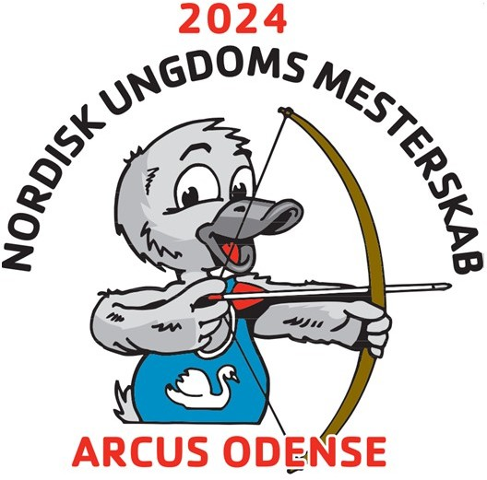

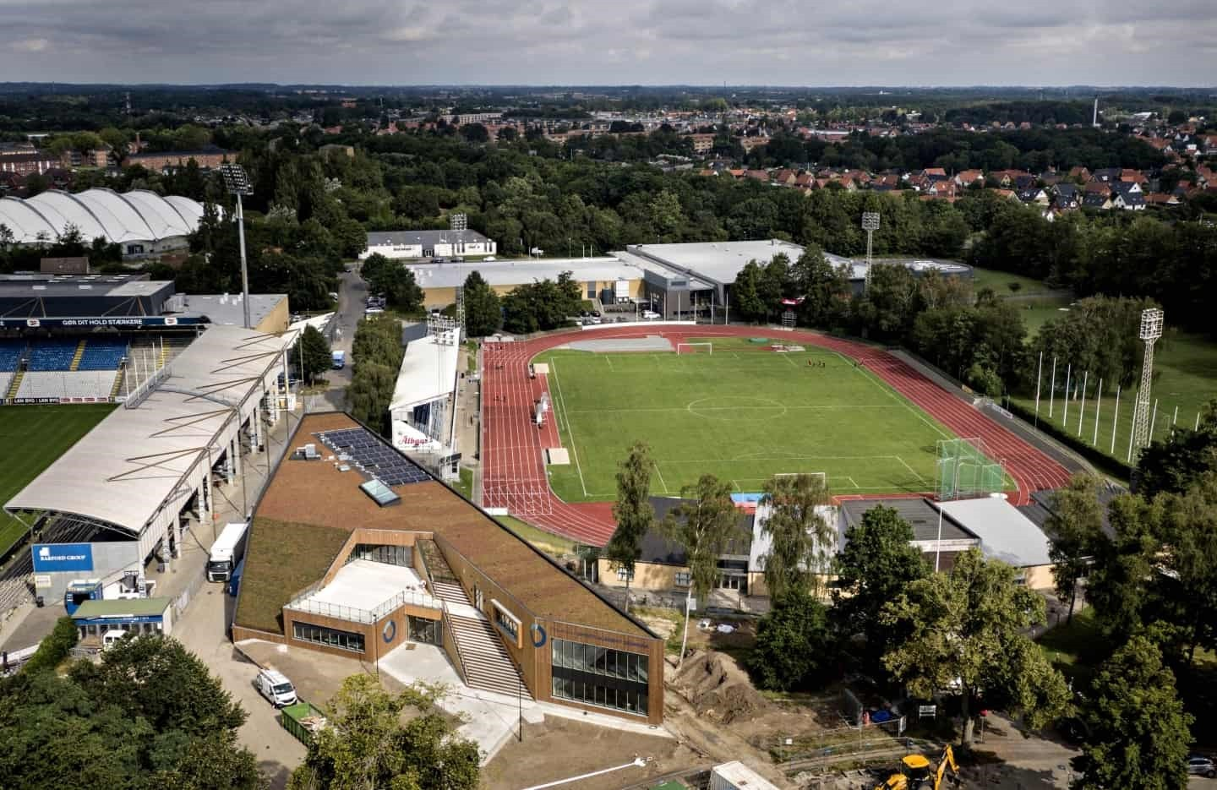
View of a part of Odense Sports Park with Odense Athletics Stadium, where the shooting will take place.
The brown building at the bottom of the picture is Sports Academy Denmark, where most of the archers will be accommodated. In the hall behind the stadium, all meals are served by a professional catering company.

Shooting
Competition will be held in all bow types and age categories according to the WA Nordic rules. Additionally, each class is divided between boys and girls.
The youngest allowed age is archers born in 2011. The oldest allowed age is archers born in 2004.
All archers must bring identification such as a passport with documentation of their birthdate and year.

70 m | 60 m | 50 m | 40 m | 30 m
RU21 (122 cm) | RU18 (122 cm) | RU21 Open (122 cm) | RU16 (122 cm) | BU16 (122 cm)
 |  | CU21 (80 cm) | CU16 (80 cm) | LU16 (122 cm)
 |  | CU18 (80 cm) | BU18 (122 cm) | LU18 (122 cm)
 |  | BU21 (122 cm) |  | LU21 (122 cm)
 |  |  |  | TU16 (122 cm)
 |  |  |  | TU18 (122 cm)
 |  |  |  | TU21 (122 cm)

RU: Olympic Recurve - CU: Compound - BU: Barebow - LU: Longbow -TU: Traditional
RU21 Open is a special NUM class. All archers in Olympic Recurve who are not comfortable shooting the long distances can participate in the RU21 Open class. This class is open to all archers, ranging from 13 years old to 20 years old, but it is likely most relevant for the U18 and U21 age groups.
Finals and medal ceremonies will be held in this class like the other classes.
Only accredited archers and coaches have access to the shooting range itself. Parents and spectators are directed to the stands behind the shooting line. The stands are covered and can accommodate up to 8.000 spectators. From all seats in the stands, there is a good view of the entire shooting range.
Each nation is allocated one coach accreditation for every 3 archers they have registered. Coaches are encouraged to wear their nation's T-shirt

Official Schedule
Preliminary schedule subject to changes.

Thursday, July 4th
10:00-13:00  13:00-16:00  14:00-15:00  15:15-16:00  17:00-17:30  18:30 | Arrival and accommodation.  Official practice.  Equipment inspection for all archers.  Team Captain Meeting.  Parade and official welcome.  Dinner.

Friday, July 5th
7:30-8:30  9:00-9:20  9:20-11:30  11:30-13:00  13:00-13:20  13:20-15:30  16:00-18:45  19:00 | Breakfast.  Warm-up group 1.  Qualification round group 1.  Lunch in two groups. Group 2 first, followed by group 1.  Warm-up group 2.  Qualification round group 2.  Individual elimination finals.  Dinner.

Saturday, July 6th
7:30-8:30  9:00-9:20  9:20-11:00  11:00-11:30  11:30-13:00  12:00-18:00  18:00-18:30  19:00-22:00 | Breakfast.  Warm-up.  Individual elimination finals.  Individual bronze finals.  Lunch in two groups.  Individual gold finals with alternate shooting.  Medal presentation.  Banquet with entertainment by the H.C. Andersen parade.

Sunday, July 7th
7:30-8:30  9:00-9:20  9:20-12:00  12:30-13:00  13:00 | Breakfast.  Warm-up.  Team finals.  Medal presentation.  Closing remarks and farewell.

Food and drinks
All meals are provided by a professional catering company and served in the handball hall next to the stadium.
For breakfast, there will be juice, milk, water, coffee, and tea. For lunch and dinner, water will be provided.
For lunch and dinner, there is an option to purchase soft drinks, mineral water, beer, etc. All meals must be ordered upon registration.
Meals can be purchased in three combinations, and we recommend purchasing the 'full package' for all participants utilizing our accommodation offer.
The banquet is included in the entry fee for archers.

Meal | Full package | Half package | Banquet
Dinner Thursday | X | X
Breakfast Friday | X
Lunch Friday | X | X
Dinner Friday | X | X
Breakfast Saturday | X
Lunch Saturday | X | X
Banquet Saturday | X | X | X
Breakfast Sunday | X
Snack-pack Sunday | X | X
EUR Price Archer | 160,00 | 120,00 | 0,00
EUR Price Others | 210,00 | 170,00 | 50,00

Accommodation
We offer accommodation in two price categories:
- In the hall/meeting room with a bring-your-own air mattress etc.,
- In 2-3-4 person rooms with beds and most of the rooms have own toilet and bath. Additionally, there will be exceptional availability for single rooms.
All the beds have duvets and pillows. In some of the rooms you shall bring your own bed linen.
- ​

Hall/meeting room by the field  Bring mattress + bedding.  Thursday to Sunday | 4-person rooms by the field Bring bed linen.  Thursday to Sunday | 2-3 person rooms 3 km from the field Fully made beds.  Thursday to Sunday | 1-person room  3 km from the field Fully made bed.  Thursday to Sunday
EUR 30 per person | EUR 130 per person | EUR 130 pr person | EUR 190 pr person
Extra night (Wednesday) EUR 10 per person | Extra night (Wednesday)  EUR 70 per person | Extra night (Wednesday)  EUR 70 per person | Extra night (Wednesday)  EUR 70 per person

The rooms will be allocated according to preferences as much as possible, but in case of overbooking, we may need to assign different rooms than those requested.

How to arrive
By private plane to H.C. Andersen Airport:
We arrange pick-up at the airport, which is located 20 minutes from the stadium. Contact us for more information.
By flying to Kastrup (CPH):
Head down to the train station in the basement of Terminal 3 at the airport and take the train to Odense. From Odense train station, the light rail departs from the station (heading towards Tarup) and goes directly to the Stadium.
The Odense light rail and city buses use the same ticketing system. Train tickets are valid (except for orange tickets). Additionally, at all stops, it's possible to purchase a ticket by scanning a QR code. The ticket is valid for 1 hour and 15 minutes. The price is 15 kr for adults and 10 kr for youths under 26 years old. Upon arrival for foreign archers, we will have a person to pick up nation groups at Odense train station.
By train:
From Odense train station, the light rail departs from the station (heading towards Tarup) and goes directly to the Stadium.
By long-distance bus:
From Parking South, the light rail departs (heading towards Tarup) and goes directly to the Stadium.
By car:
Parking options are available at Stadionvej 25, 5200 Odense V, and there are also parking options on the west side of the stadium, Møllemarksvej 71, 5200 Odense V.

Deltagere fra Norge skal møte i København om ikke annet er avtalt/spesifisert.

