Hi all!

We would like to wish everybody welcome to MOT - Mushers Of Tomorrow
and hope many want to participate this year!
This year we can open up for 40 participants.
Age: from the year you turn 13 until the year you turn 18.

Photo: Åstjern Mat og Natur
Place: Åstjern Mat og Natur, Åstjernplssen, 2760 Brandbu, Norway

Website: https://www.astjern.no
Date: arrival monday june 28. - departure sunday July 4.
Price: 6500 NOK/person. Includes accommodation and four meals a day.

We arrange transport for foreign kids from the airport to Åstjern. If need to come earlier or departure later we will try to arrange sleepover at a participant.

It is possible to borrow a dog for the whole week. Make sure to let us know the need when you sign up.

Åstjern is a beautiful and quiet place in the forest, with a large amount of possibilities for training and activities.
There is possibilities to take a swim, so bring swim wear.
Åstjern will provide us all with food and drinks (breakfast - lunch – dinner – evening meal). It is possible to buy a little extra food or snacks at own expense in the grocery shop 10 km. from the camp.

All participants will get a MOT sweater and a team t-shirt!

As previous years we are thinking to finish the camp with a blast and show off everything you have learned during the camp in a small sleddog relay competition, before leaving home again.
This will take place on Saturday.

The Entry form:
Press the red button marked «Påmelding»

Questions?
Leader of MOT: Fanny Wedde – fanwed@gmail.com - +47 98545813
Head coach: Pinja Korpela – pinjakorpela@hotmail.no - +47 45239969

Follow us on
https://www.facebook.com/SHKSnorway
https://www.instagram.com/mushers_of_tomorrow/

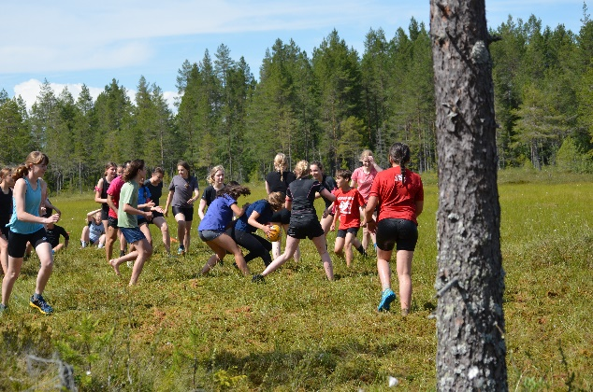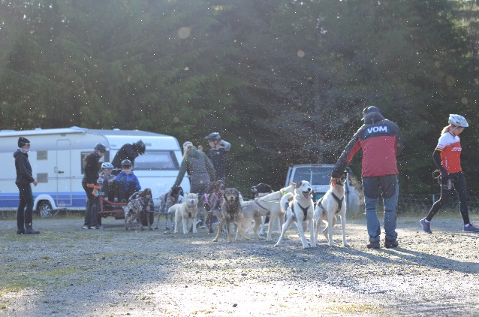

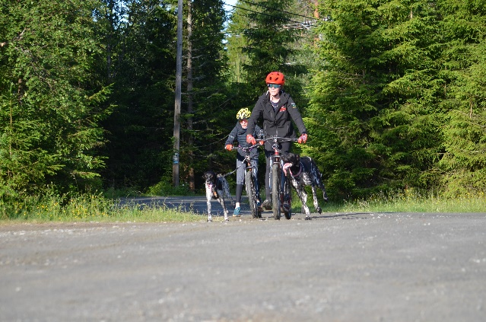 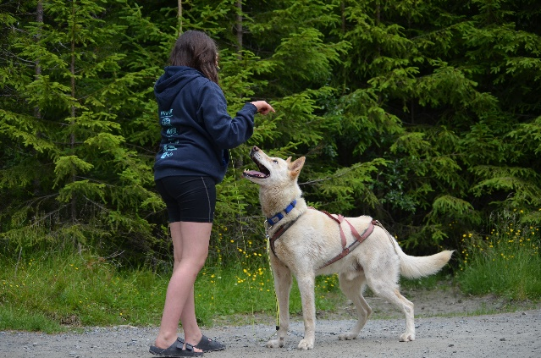
Photos: MOT 2025

