
Participant information – Edition 1-2017 (more info to come)
Bislett 24-hours November 25th-26th 2017
Website: www.romerikeultra.no/p/24681/info-in-english
Facebook: www.facebook.com/Bislett24
Organizer: Romerike Ultraløperklubb www.romerikeultra.no

Hi runners
There is now only 23 days left to "the year's longest Christmas party" for the 11th time to be arranged on the indoor track underneath the Bislett tribunes. The race was sold out several months ago, but we have facilitated resale of starting places - see information on the website - and we think most runners who want to participate should be able to get hold of a starting place, and those who are prevented from starting will be able to sell their place.
We therefore think the final number of runners starting at 10:00 on November 25th will be very close to 160, which is the absolute maximum we think the arena can hold. For that reason, we start by asking for your attention and that you follow the rules and instructions given, so that everyone will have the best possible race. More on this later in this document.
Romerike Ultraløperklubb is new as an organizer this year, but many of us have helped out with this race for all or many years - and our aim is to make a just as good event as our predecessors did.

TIME SCHEDULE:
SATURDAY 07:30 The doors open at Bislett Stadion
SATURDAY 08:30 Distribution of start numbers
SATURDAY 10:00 Start
SATURDAY 16:00 Change running direction
SATURDAY 22:00 Change running direction
SUNDAY 04:00 Change running direction
SUNDAY 10:00 End signal and final measurement
SUNDAY 11:30 Prize ceremony Bislett24 and NM

ACCESS:
For those arriving by car, it is recommended to use one of the nearby parking lots. Parking at Bislett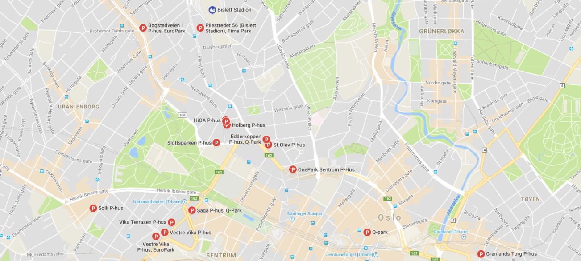
The entrance to the indoor track at Bislett is in “Sofies gate” even though the address is “Louises gate 1”. The entrance is marked with Bislett24, and the door is open from Saturday 07:30. There are stairs (and elevator) two floors down to the running track, changing rooms and arena area.
This is also the entrance for spectators and supporters.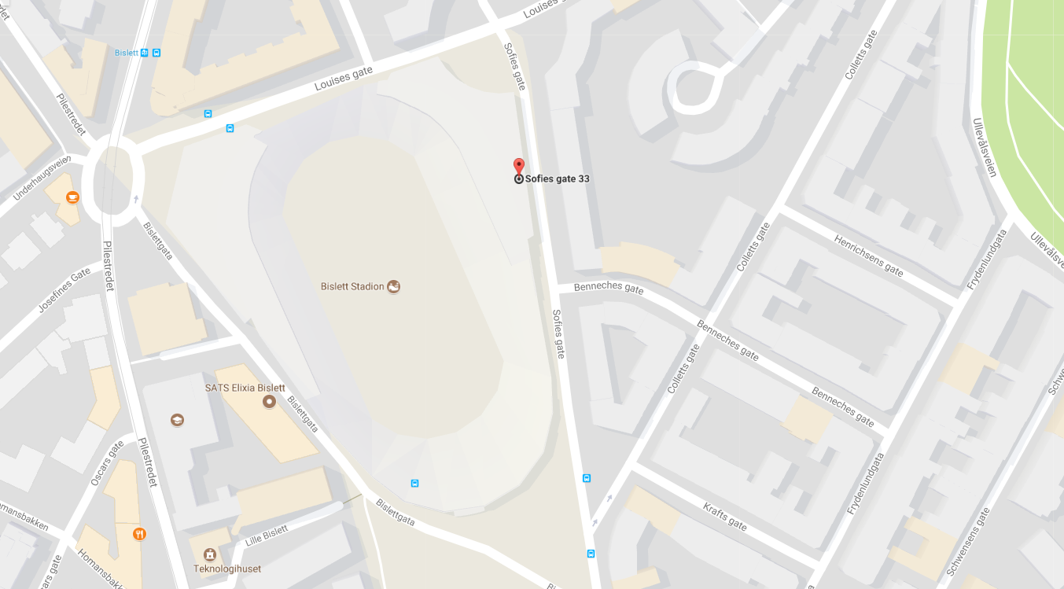

DISTRIBUTION OF START NUMBERS:
Distribution of start numbers will take place in the area you will meet on arrival at the indoor track. There is no possibility for post-registration or transfer of start number this day, this must be completed by November 20th.
If we find someone running with someone else's number, they will be disqualified. This also applies if it is discovered after the race.
Everyone runs with two chips attached to the starting number. The starting number must be unaltered, always in front and always visible. It is therefore not permitted to fold or cut in the starting number. If you destroy the chip, no rounds are counted.

WARDROBES AND TOILETS:
Wardrobes and toilets are in the arena area on your right side when you arrive at the track. We will establish a separate service for the storage of valuables. The toilets are cleaned and washed every hour.

SUPPORT ZONES:
The main area for support is in the sprint zone opposite to where you reach the track. We will set out tables that can be used by runners and those who support runners. However, we do not have enough tables nor the space for everyone. Therefore, we ask you to be generous to others and share space; generosity and helpfulness are a bit of the essence of ultra-running. If you bring supporters, then ask them to exercise the same generosity to fellow runners. Feel free to have your own camping table and the like, which can be set up behind the other tables.
The organizer's service station is at one end of the sprint zone.
There is also room for some support and depots on the entrance side, to the left of where you enter. Follow the organizer's instructions as part of the space is reserved for first aid and massage.

FOOD AND BEVERAGE:
There will always be a good selection of food and drinks at the service station. The energy drink will be Winforce Carbo Basic this year too. Hot meals will be served throughout the day. We will provide more information about this in the next newsletter, and we will provide detailed information at the service station.
In addition to the hot meals served we will always have the following available: fruit, bread with varied toppings, chips, water, coke, winforce, coffee, tea, milk +++
Of course, we will also serve some candy (chocolate and the like), but our own experience is that this is the main source of nausea and lack of appetite for most runners - so we recommend you to be somewhat self-restrained with this service.
If you rely on or want a special diet, we recommend that you bring this yourself. But please feel free to contact us in advance.
Helpers, supporters, family and friends do not have access to the service station. It is not allowed for anyone other than the runner to pick up food and / or drink from the service station. We have no capacity to serve anyone other than those participating in the race. Please share this information with those who may support or visit you.
There is a possibility that we will be able to establish a serving station for the audience and supporters in the arena where you came down to the track.

Special offer on Winforce Cabo Basic:

Our supplier of sports drinks offers all participants 20% of Winforce products throughout November. The products can be bought here: WINFORCE
Use the discount code: Bislett24

RULES:
All runners have the same right to run or walk in the inner lane - regardless of speed or position during the race. Passage is done outside the runners in the inner lane, although it causes some extra meters for the fastest runners during the day.
Exception: If two or more racers walk next to each other there should always be a whole free lane to the inside of where they walk. All organizers and participants are entitled to point out breach of this practice.
Only runners and organizers are allowed to be on the track. Neither supporters, children, parents or others are allowed to follow the runner on the track or to provide support outside the service zones. Repeated violation leads to disqualification. Everyone are, of course, entitled to move along the outer wall to get to the toilets and other errands in the arena area on the wardrobe side.
It is not allowed for runners to stop, sit or lay down on the track. The exception is of course if the runner should be injured.

SPECTATORS:
All non-participants, supporters or organizers are kindly asked to stay to the arena area, where they arrived at the track. This also applies to the runner’s family. But by all means; You are welcome to invite friends and family to visit the arena to cheer on you and the other runners. Just tell them where they should be.

RACE PROCEDURE:
The start will be in the arena where you reach the track. The speaker will also be stationed here, timing will take place here, a screen with current results can be found here and a webcam will also point to this area.
Each round is 546 meters. Please note that you must not go back-and-forth over the timing matts during the race. If you have passed the toilets or something else, do not go back but wait till the next round. Also, avoid stopping and talking at the timing matts.
Change of direction every 6 hours takes place in the immediate vicinity of the timing matts. This will be thoroughly announced by the speaker, just follow the instructions and you'll be fine. On the other hand, be aware that if you are outside the track (resting, on the toilet, etc.) when the change of direction is done, check the way the runners run when you are ready to proceed.
One important, or perhaps the most important, rule is that everyone should be polite to each other and to anyone who uses their free time to help those who run.
In order to make the work easier at the service station, the following rule applies; It is not allowed to grab food or drink while running. We do not have time to clean after runners who spill or make a mess. Nor is it allowed to pour sports drinks or other sugary drinks on the track. Act as if you were indoors - because you are!
Use designated boxes (there will be many of them) for any garbage. We will get grumpy if we find trash on the track. Do not discard cups and other trash from a distance - drop it into the boxes. Believe us; you will not lose any time!
There is not much we can do about the temperature. The indoor track is not designed for so many people over such a long time, but we will do the best we can by opening and closing doors. Some may want it warmer while others want it colder. Remember; Those who help you should also have a pleasant temperature. Do not complain, but adapt to the conditions.
It is not allowed to run shirtless.
It is allowed to move outside the track to rest, receive support, go to the toilets and, at worst, take a nap where possible. But, this is a race contest, so we have not made any special arrangement for those who want to sleep. When going back to the race, you must do so at the place you left the track.

ABOUT THE FINAL MEASUREMENT:
When the speaker announces that the time is out after exactly 24 hours, you must stop immediately and wait where you are until the final measurement is done and your extra meters are added. You will be notified when it is OK to leave this point. This can result in up to 10 minutes of waiting, depending on where you are on the track.

FIRST AID AND MASSAGE:
‘Norsk Folkehjelp’ will be present throughout the race. They are present to take care of serious injuries. If you are in doubt about your own or another runner's health, do not hesitate to contact them or one of the organizers


Our partner ‘Ryenklinikken’ will also be available to runners throughout the day for free massage and injury prevention.

SPEAKER:
There will be one or two to speakers during the race, but we will also have some quiet periods. The sound will - if everything works normally - be heard throughout the entire track. There will be music, greetings to the runners and some results service.
If friends or family want to send greetings, this can be done to an address we will provide later. You will also get an address where you can send music wishes, but we cannot promise to fulfill all wishes. Link to live results and webcam will also be made available later.
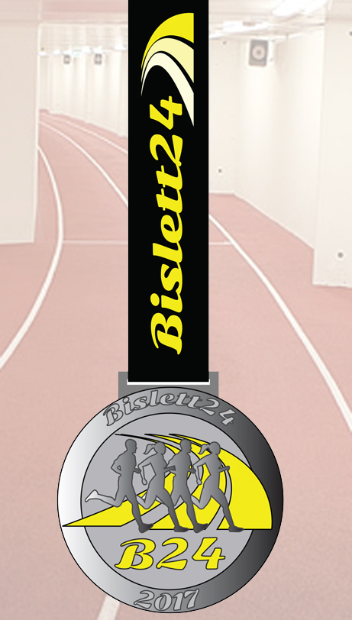
PRIZE CEREMONY AND AWARDS:
The prize ceremony will take place 1,5 hours after the end signal. That is the time we need to prepare all the results.
• Prizes are awarded to the top three women and men in total
• Class Winner Prizes are awarded
• Official NC Medals * are awarded in the Senior Class
• NC veteran medals are distributed in all age classes
• There are some prizes drawn from those who are present
* NC participation for seniors and veterans requires a membership in a club affiliated with NFIF. Minimum distance for the allocation of NC medal for veterans is 100 kilometers.
• In addition, anyone who runs 150 kilometers (men) or 130 kilometers (women) will receive the race's prestigious performance medal.

PARTICIPANT SHIRT:
In addition to the starting number, you will also get the participant shirt, there will be a separate e-mail about the registration of size.
RESULTS:
In a time-based race, the term DNF does not exist. Once you have finished one round (546 meters) you have a result. If you stop before the end signal, you will be credited with all the rounds you have completed.
Along the way, you can track how far you've been on a screen in the speaker area, fans and supporters can follow the live results online, and final results will be available on Ultimate.dk's website, on the race website and on kondis.no.
Each round is 546 meters.
The track record for men is 257,606 km (Bjørn Tore Kronen Taranger 2015) and for women 228,432 km (Maria Jansson 2014).

NETWORK:
It can be a bit challenging with networking in the arena area. Wifi is reserved for organizers. Participants, supporters and audiences are referred to the 3G/4G coverage.
We will try to organize an extra result screen in the support area at the sprint track, so that those who support the runners can keep themselves informed about ongoing results.

WELCOME:
Welcome to Oslo and legendary Bislett on November 25th and 26th.
If you have questions about the event, you can send an email to one of the race leaders, and if things are of general interest, we will include it in a later newsletter.
We wish you good luck with the preparation the coming weeks and we will do our best to help you achieve your goals.

With regards from the race leaders
Marit marit_kbb@live.no and
Olav olav@samgla.no

NB:
A few days after the competition, you will receive a survey that we hope you and all other participants will participate in. This is essential for making an even better (if possible) event in 2018 and later.

