

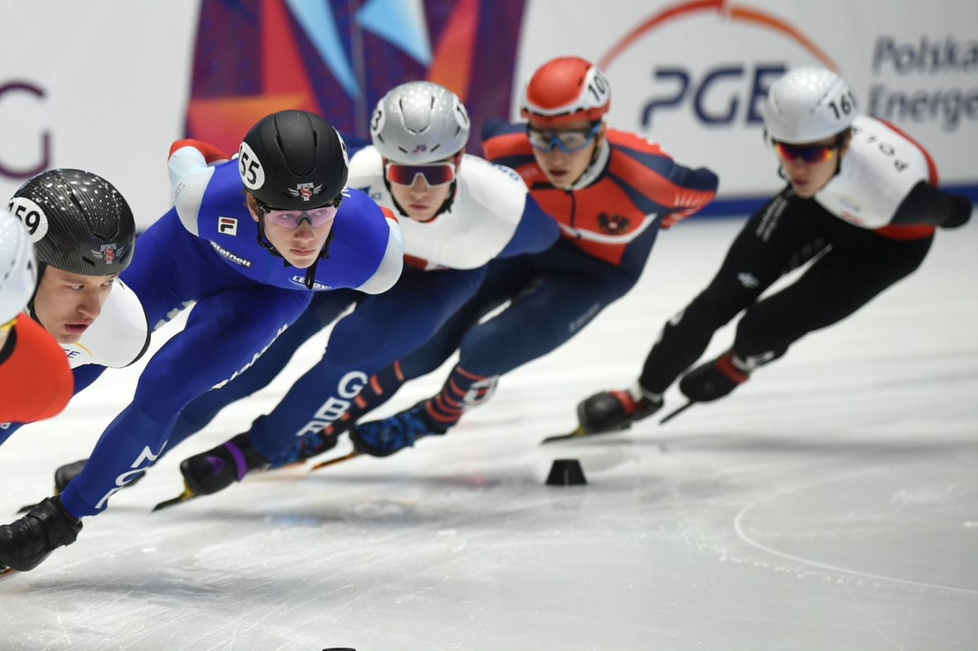

Official invitation, OSK Open/ 2 National league Norway cup
The Norwegian Skating Federation and Oslo Speedskating Club (OSK) have the honor to invite you to the OSK Open/ 2 National league Norway cup. The competition will be held in Oslo 3-4 December, 2022. International skaters will not be eligible for points and ranking in the Norway Cup, but will race against all skaters in OSK Open.
The competition will be organized in accordance with the 2022 Regulations of the International Skating Union, the Memorandum for European Competition Series 2022/2023 and the conditions included in this announcement.
Entries are open to all ISU members and their affiliated clubs. In the case of an unmanageable number of entries .
Categories for Women and Men
The competition is open for all categories including skaters from Special Olympics.
Conditions of Contest
The Qualifying Schedule on each distance shall be based on an "All Final System" in all categories. The All Final System is used in order to guarantee a minimum number of races to all participants. The organizer reserves the right to change the program for distances and classes due to number of entries or other circumstances.
Distances
Senior and Master | 1500m | 500m | 1000m | (Relay TBC)
Junior C – A | 1500m | 500m | 1000m | (Relay TBC)
Junior F -D | 777m | 500m | 1000m
Recruits | 333m | 111m | 500m
Special Olympics | 777m | 5000m | 1000m

Preliminary program
Day | Time
Friday, December 2nd

Friday, December 2th, 18:00 - 20:00 Registration and helmet covers
Saturday, December 3th 08:00 – 09:00 Registration and helmet covers
Saturday, December 3th 08:30 – 09:45 Warm up
10:00 Start of competition
15:00 End of competition (depending on entries)
Sunday, December 4th 08:30 – 09:45 Warm up
10:00 Start of competition
15:00 End of competition
The program is tentative and subject to changes by the organizing club and the referee.
Entries
Entries are open to all ISU members and their affiliated clubs.
All entries for the OSK Open/ 2 National league Norway cup must be made on www.shorttrackonline.info
Clubs and Federations have a special password for login to the entry page for International Competitions. If not available, it is possible to apply the webmaster for a login through the website.
The final entry form must be submitted not later than November 28th, 2022 and shall be made via www.shorttrackonline.info
Entry Fee
An entry fee of 40,00 EUR (400 NOK) Juniors C-Masters and 20 EUR (200 NOK) for Recruits – Junior D and Special Olympics must be paid to the organizers for each accredited person, e.g. for every athlete. All Norwegian skaters must pay through bank transfer November 28 at the latest. Please pay the total amount for all skaters per club! Please indicate club name and how many skaters from the club. Account nr 60390872774 (IBAN NO1760390872774, BIC NDEANOKK)
International skaters can pay with credit/ debit card at the rink.
Meals
There will be a café in the ice rink. No lunch deals.
Track
The track is an artificially refrigerated indoor ice surface with the measures of 28x58 meters, protective padding will cover the boards. The standard track is 111,12 meters to the lap with measured curves of 8,50 meters and there will be 7 markers used to establish each curve. The length of the straight is 28,85m. Besides the original track there will be 4 tracks set up to preserve good ice conditions. One finish line will be used for all tracks.
Award of Prizes
Prize for the first, second and third classed in the final results for Junior C - Masters ladies and men. All other classes will be awarded prizes.
Medical Assistance
Doctor will be present on competition days. There will be an adequate response time for an ambulance to be on site in case of need.
Medical Insurance
It is the sole responsibility of each Member, on behalf of its participating clubs, to ensure or provide medical and accident insurance for their athletes. Proof of such shall be requested by the Organizing Committee. See I.S.U. Rule 119.
Liability
In accordance with I.S.U. Rule 119, the Organizing Committee assumes no responsibility with respect to medical, bodily or personal injury or property loss or damage sustained or caused in connection with this Competition.
Ice rink
Sonja Henie ice Rink: Middelthuns gate 26, 0368 Oslo
Map: https://www.google.no/maps/place/Sonja+Henie+Ishall/@59.926554,10.7092035,15z/data=!4m5!3m4!1s0x0:0x783aa4455f89a1f0!8m2!3d59.926554!4d10.7092035
Organizing Committee
For information about the OSK Open/ 2 National league Norway cup you can contact:
Christian Pedersen, Tel: + 47 99 28 76 68, E-mail cfredpe@gmail.com (Contact preferred by mail)
Hotel-accommodation:
There are plenty of hotel options in Oslo close to the rink. Please use the address of the rink as your search criteria to find your preferred hotel.
We look forward to seeing you in Oslo

